요구사항 명세서 : <https://www.notion.so/335111f0eabb4d8ea6bc6d7e73850f73>

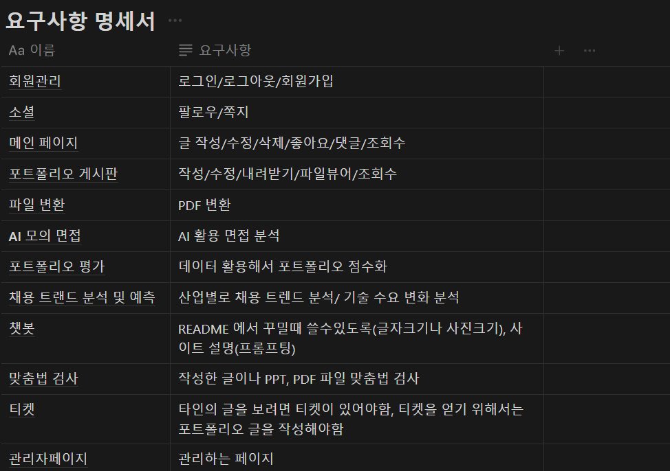

기능 명세서 : <https://www.notion.so/2eb7e3ed99f24d398d9d5300036b8dc8>

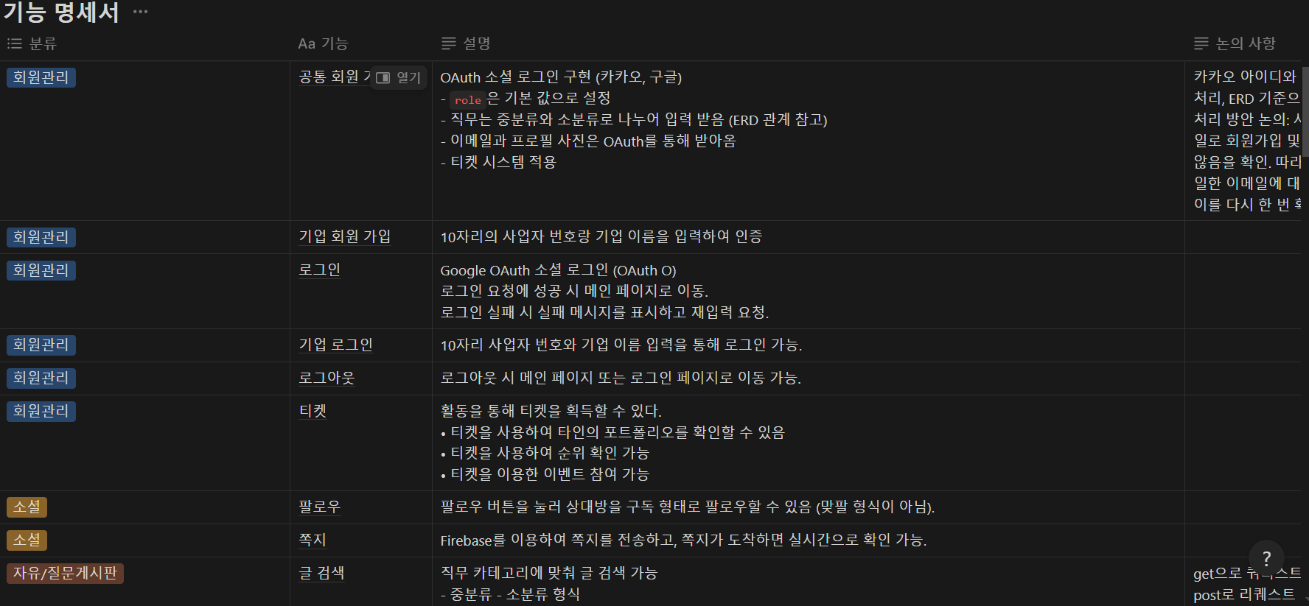

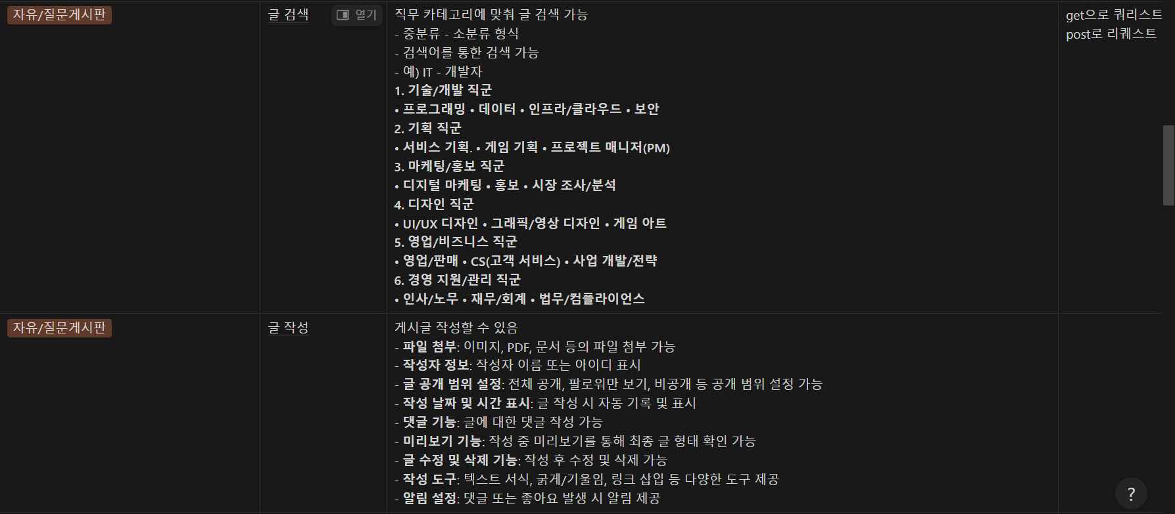

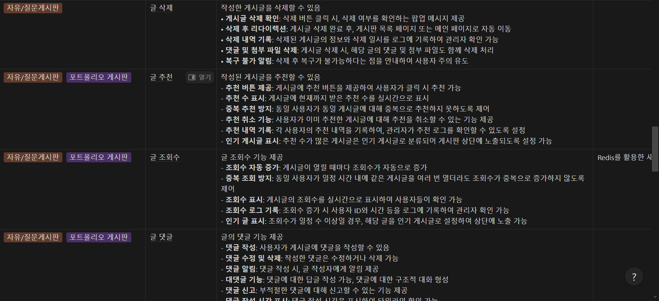

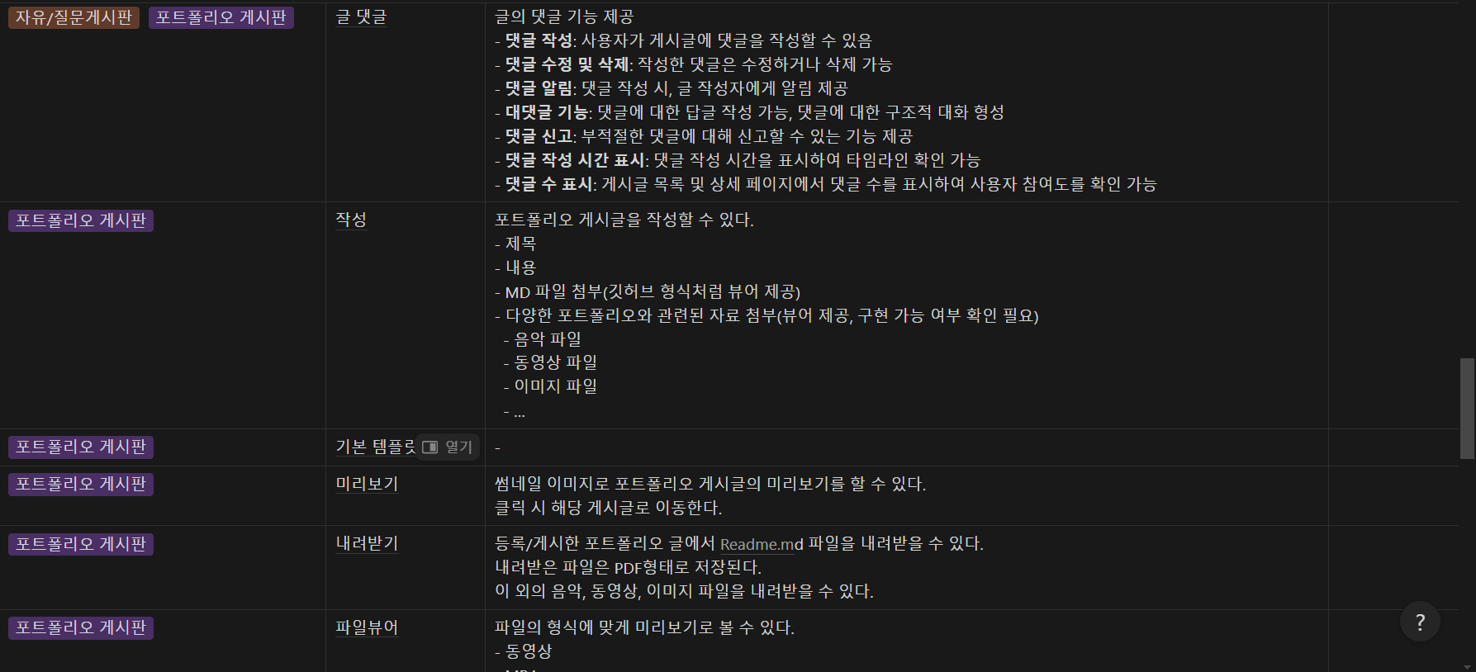

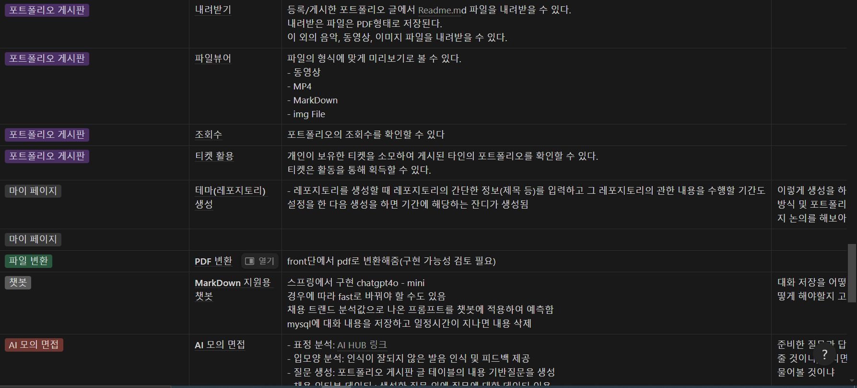

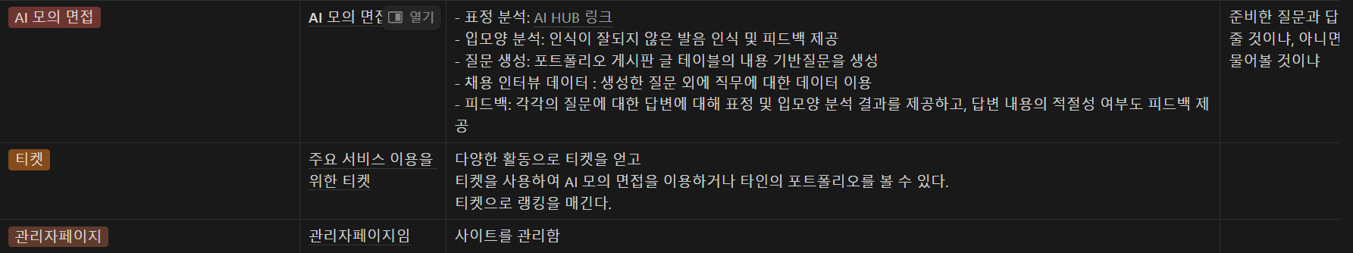

화면 명세서 : <https://www.notion.so/7acc468ecbaa489ca32ca2e49a83356a>

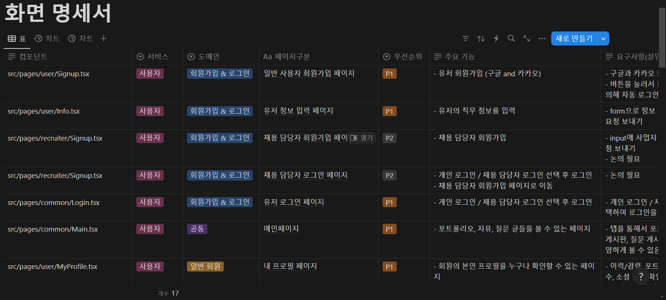

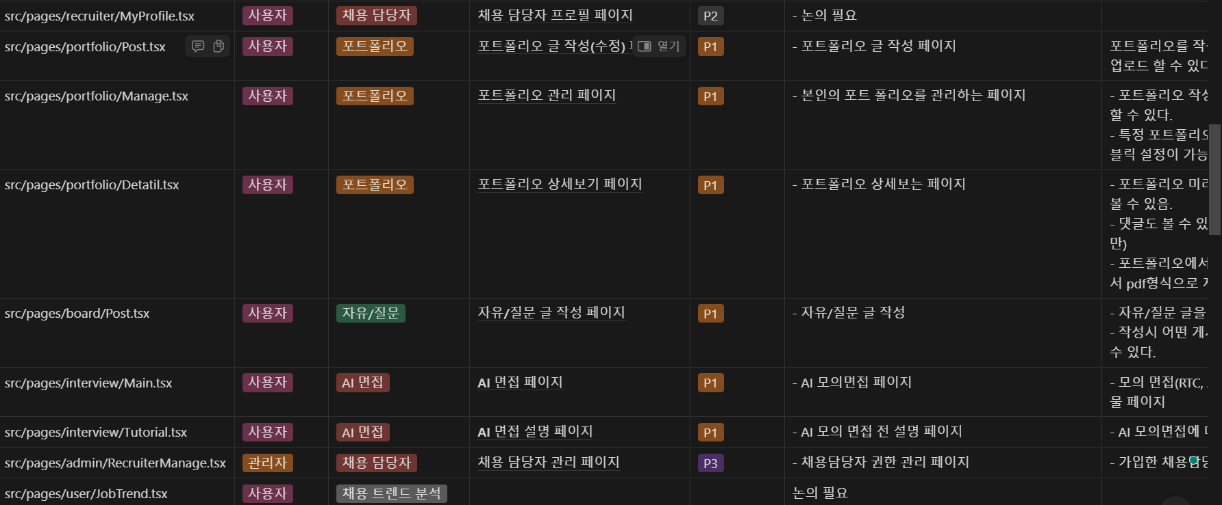

API 명세서 : <https://www.notion.so/API-a12a000bd5834aefb46030dcd287abfc>

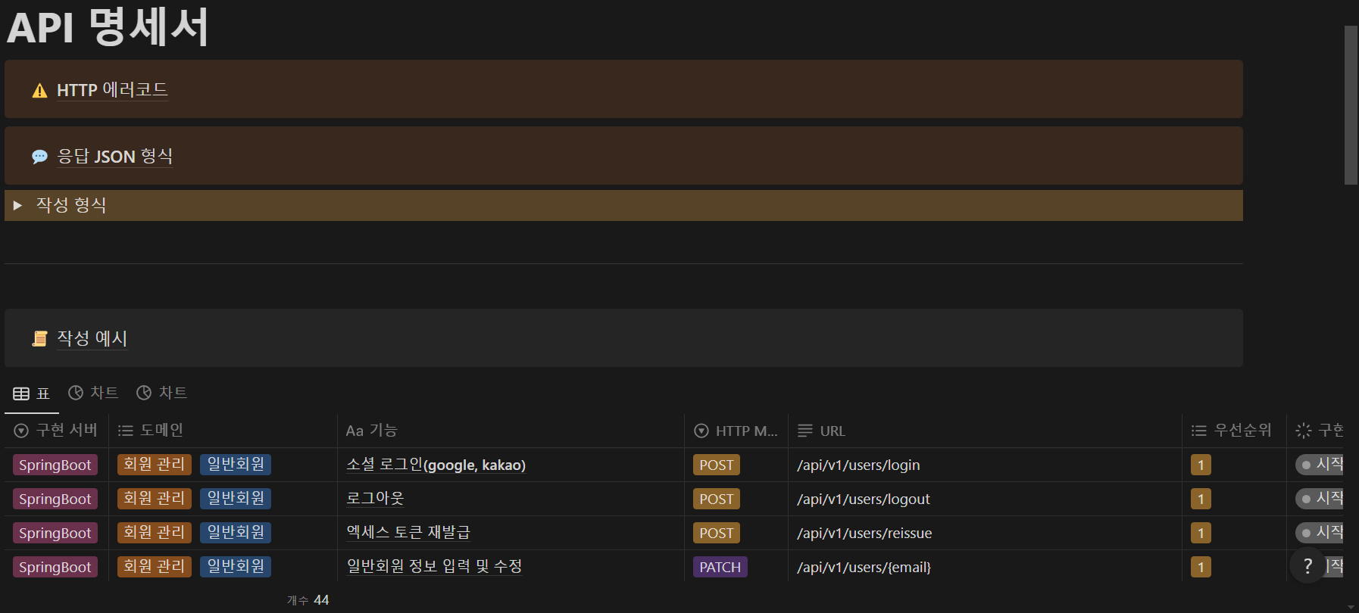

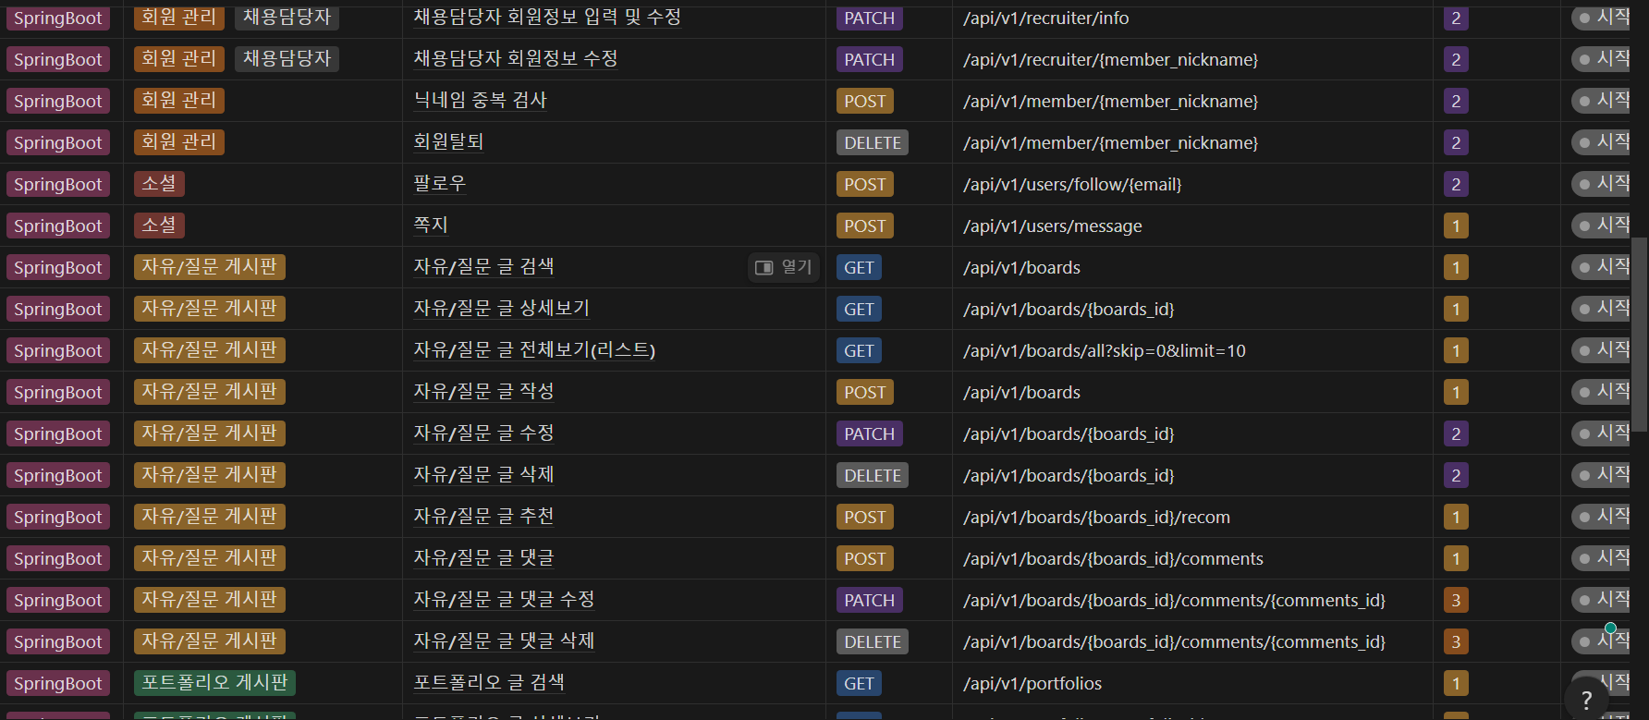

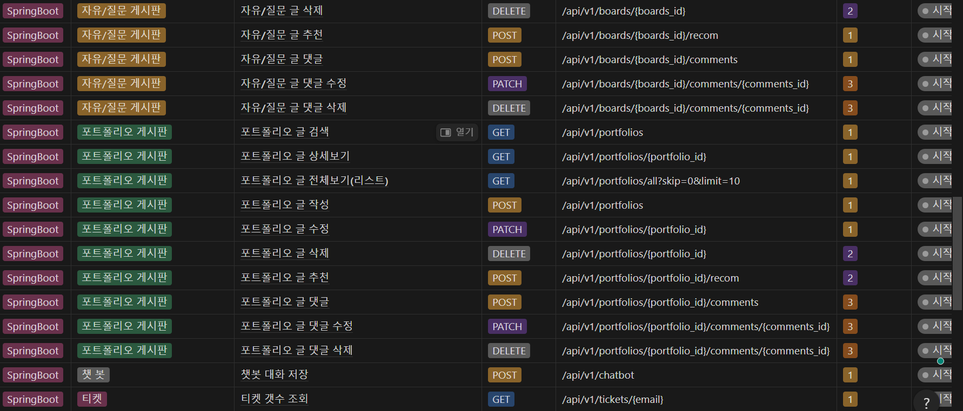

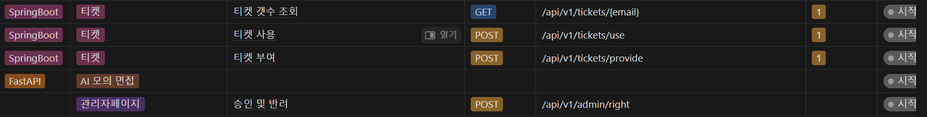

ERD : <https://www.erdcloud.com/d/KaZhAHuJ4GJgFnkNR>

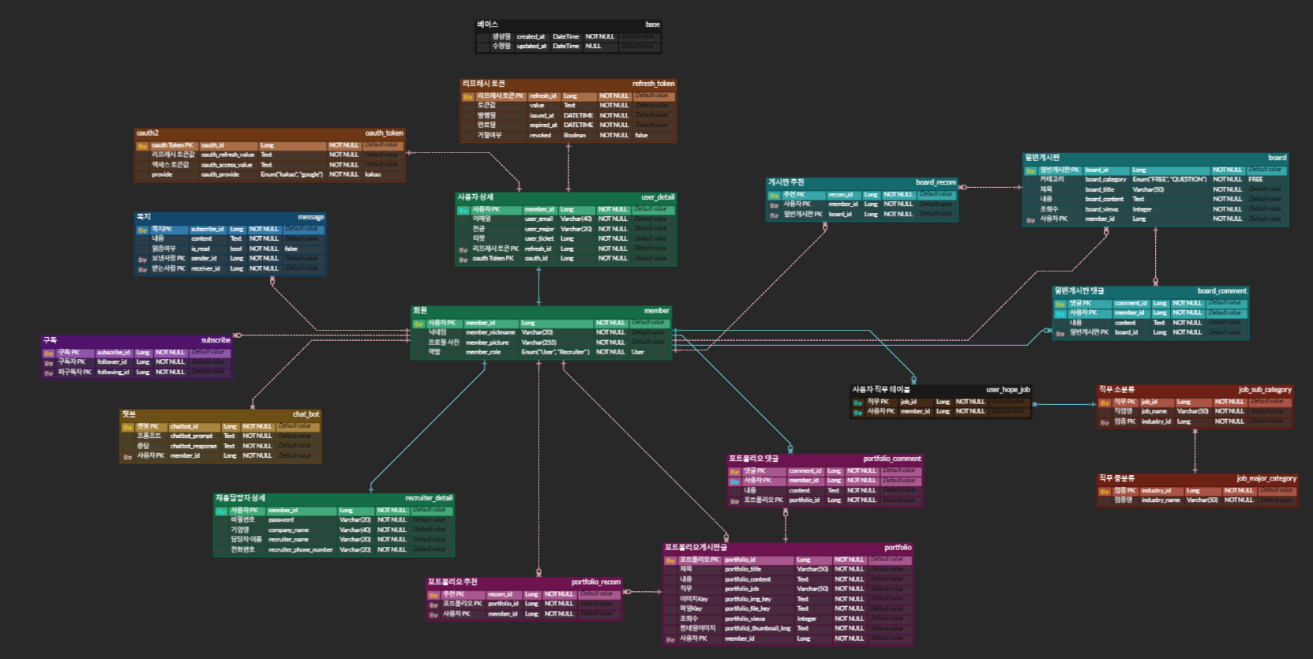

목업: <https://www.figma.com/design/tAHC2wibgiS1Gff4FaeyMn/%ED%9D%91%EC%88%98%EC%A0%80-%EA%B0%9C%EB%B0%9C%EC%9E%90?node-id=0-1&node-type=canvas&t=ZzC9yC138QNLMEch-0>

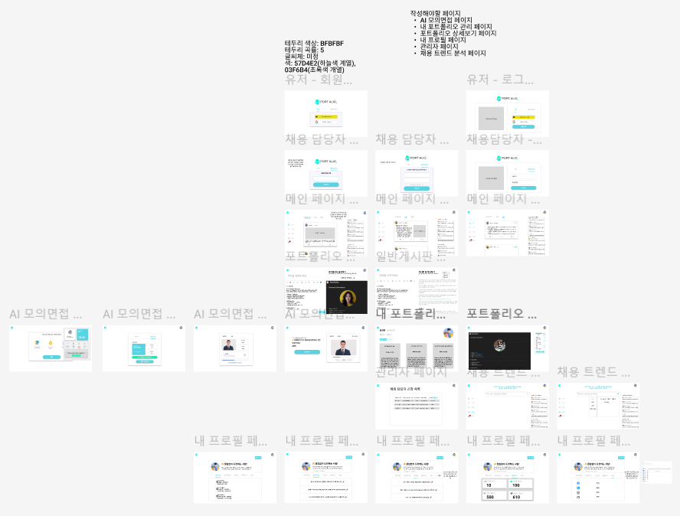

웹 아키텍처 : <https://www.notion.so/11f17b102d5d81fe8bd6dd1c461c4b2e>



플로우차트 : <https://www.canva.com/design/DAGUWH1xWaQ/O4N9TBxnnZJqZMJhYVgNkg/edit>

